| **Higher Level** | | **Standard Level** | | **Core Elements** | | **Total Score** | |
| --- | --- | --- | --- | --- | --- | --- | --- |
| **Subject** | **Full Score** | **Subject** | **Full Score** | **Subject** | | **Full Score** |  |
| 1 | 7 | 1 | 7 | Extended Essay | | 3 | 45 |
| 2 | 7 | 2 | 7 | Theory of Knowledge | |
| 3 | 7 | 3 | 7 | Creativity, Activity, Service | |

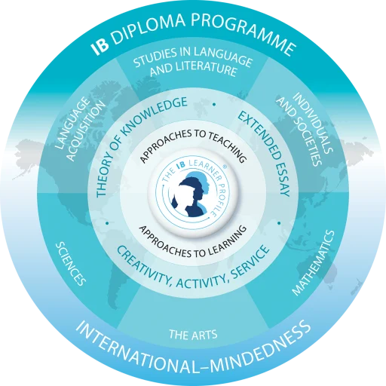

* Group 1 Studies in Language and Literature
* Group 2 Language Acquisition
* Group 3 Individuals and Societies
* Group 4 Sciences
* Group 5 Mathematics
* Group 6 The Arts

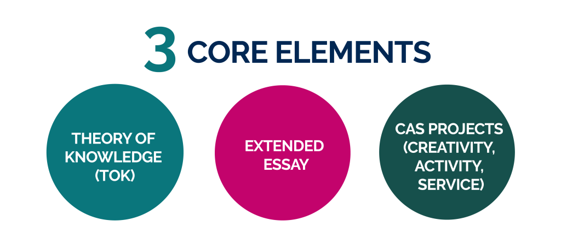

TOK

Theory of Knowledge, also known as TOK, is one of the core elements of IB that is mandatory for all students. In order to achieve an IB Diploma, you should pass the TOK, by getting a minimum of D. TOK plays a special role in the IB Diploma Programme, by providing an opportunity for students to reflect on the nature of knowledge, and how we know what we claim to know. TOK requirement is central to the educational philosophy of the DP. The TOK course is assessed through an exhibition and a 1,600-word essay.

* The exhibition requires the students to create an exhibition of three objects that explores how TOK manifests in the world around us.
* The essay focuses on a conceptual issue in TOK. It may ask students to discuss the claim that the methodologies used to produce knowledge depend on the use to which that knowledge will be used.

TOK aims to make students aware of the interpretative nature of knowledge, including personal ideological biases - whether these biases are retained, revised or rejected.

It offers students and their teachers the opportunity to:

* Reflect critically on diverse ways of knowing and on areas of knowledge
* Consider the role and nature of knowledge in their own culture, in the cultures of others and in the wider world.

TOK prompts students to: (link to TOK prompts)

* Be aware of themselves as thinkers, encouraging them to become more acquainted with the complexity of knowledge
* Recognize the need to act responsibly in an increasingly interconnected but uncertain world.

TOK also provides coherence for the student, by linking academic subject areas as well as transcending them.

It therefore demonstrates the ways in which the student can apply their knowledge with greater awareness and credibility.

EE

The Extended Essay, also known as EE, is one of the core elements of IB that is mandatory for all students. In order to achieve an IB Diploma, you should pass the EE, by getting a minimum of D. EE is an independent piece of research, culminating with a 4,000-word paper.

The Extended Essay provides:

* Practical preparation for undergraduate research
* An opportunity for students to investigate a topic of personal interest to them, which relates to one of the student’s six DP subjects, or takes the interdisciplinary approach of a World Studies Extended Essay.

Through the research process for the Extended Essay, students develop skills in:

* Formulating an appropriate research question
* Engaging in a personal exploration of the topic
* Communicating ideas
* Developing an argument

Participation in this process develops the capacity to analyze, synthesize and evaluate knowledge.

An Extended Essay can also be undertaken in world studies, where students carry out an in-depth interdisciplinary study of an issue of contemporary global significance, across two IB diploma disciplines.

Students are supported throughout the process of researching and writing the Extended Essay, with advice and guidance from a supervisor who is usually a teacher at the school.

Students are required to have three mandatory reflection sessions with their supervisors. The final session, a concluding interview, is also known as *viva voce*.

The Extended Essay and reflection sessions can be a valuable stimulus for discussion in countries where interviews are required prior to acceptance for employment or for a place at university.

CAS

Creativity, Activity, and Service, also known as CAS, is one of the core elements of IB that is mandatory for all students. Studied throughout the Diploma Programme, CAS involves students in a range of activities alongside their academic studies.

It is not formally assessed; however, students reflect on their CAS experiences as part of the DP, and provide evidence of achieve the seven learning outcomes for CAS.

The three strands of CAS, which are often interwoven with particular activities, are characterized as follows:

* Creativity: arts, and other experiences that involve creative thinking.
* Activity: physical exertion contributing to a healthy lifestyle, complementing academic work elsewhere in the DP.
* Service: an unpaid voluntary exchange that has a learning benefit for the student. The rights, dignity and autonomy of all those involved are respected.

In order to demonstrate these concepts, students are required to undertake a CAS project. The project challenges students to:

* Show initiative
* Demonstrate perseverance
* Develop skills such as collaboration, problem solving and decision making.

CAS enables students to enhance their personal and interpersonal development by learning through experience.

It provides opportunities for self-determination and collaboration with others, fostering a sense of accomplishment and enjoyment from their work.

At the same time, CAS is an important counterbalance to the academic pressures of the DP.

Teacher Information:

IB Coordinator:

* Name: Tony Cartmel
* Office Location: Global F1
* Email: tcartmel@gafl.hs.kr

IB Math:

* Name: Hansol Kim
* Office Location: Domestic F3
* Email: [hkimmath@gafl.hs.kr](mailto:hkimmath@gafl.hs.kr)

IB Chemistry:

* Name: Kenneth Gassar
* Office Location: Global F1
* Email:[therealkennyg@hotmail.co.uk](mailto:therealkennyg@hotmail.co.uk)

IB Biology:

* Name: Sofia Mafe
* Office Location: Global F1
* Email:[Christeachair@gmail.com](mailto:Christeachair@gmail.com)

IB English A:

* Name: David Burns
* Office Location: Global F1
* Email:

IB English B:

* Name: Chris Reese
* Office Location: Global F1
* Email:Christeachair@gmail.com

IB Chinese:

* Name: Deng Xin
* Office Location: Global F1
* Email: dengxin198641@gmail.com

IB Japanese:

* Name: Hayato
* Office Location: Global F1
* Email:

IB Economics:

* Name: Case Shay
* Office Location: Global F1
* Email:[jcshayib@gmail.com](mailto:jcshayib@gmail.com)

IB History:

* Name: Richard
* Office Location: Global F1
* Email:

IB Korean:

* Name: Hyunjin Kim
* Office Location: Global F1
* Email: a51265899@gmail.com

IB Film:

* Name: Shane McAllister
* Office Location: Global F1
* Email: [mcallister.shanemichael@gmail.com](mailto:mcallister.shanemichael@gmail.com)

IB TOK:

* Name: Shane McAllister
* Office Location: Global F1
* Email: [mcallister.shanemichael@gmail.com](mailto:mcallister.shanemichael@gmail.com)

Advanced English Conversation (EE)

* Name: Edward (Ed) Pontee
* Office Location: Global F1
* Email: pontee.english@gmail.com